Create a profile of a place, person, or character; real or fictional

DOCTYPE:

Html area

Head area

Title: All About Jimi Hendrix

Meta tag

author: Nicholas Grande

description: A short history about the life of guitarist and songwriter Jimi Hendrix keywords: Jimi Hendrix, Guitarist, Woodstock, Psychedelic, Pioneer

Body area

Header section (*Uses an h1 and p tag to add a title and brief description of your profile)*

Heading 1: The Great Life of Jimi Hendrix

Paragraph: Often referred to as the greatest guitarist of all-time, Jimi Hendrix was born in Seattle, Washington. Hendrix’s ability to manipulate the guitar to create sounds that no one had ever heard before earns him the credibility that he has today.

Main section (*Uses an h2-3, p, ol, and ul tags to add a section titles and content to your profile)*

Section 1

Heading 2: Early Life

Paragraph: From a young age, Jimi Hendrix grew a love for the guitar. During his early career he would find himself backing for many different artists, most notably the Isley Brothers. He would eventually take his talents to London, England where he’d meet future bandmates Noel Redding and Mitch Mitchell. When all the buzz about this kid tearing it up in small clubs in London started, Hendrix would soon see himself on the climb.

Section 2

Heading 2: Coming into the Spotlight

Paragraph: Hendrix released his first album “Are You Experienced” with his band “The Jimi Hendrix Experience”. The real success came from his mind-blowing live performances. He played many notable performances in some of the biggest venues in the world, but one of his most iconic is his performance at the Woodstock Arts & Music Festival in 1969.

Section 3

Heading 2: Discography

Ordered list

1. Are You Experienced (1967)
2. Axis: Bold As Love (1967)
3. Electric Ladyland (1968)

Section 4

Heading 3: Notable Live Albums Unordered list

* + Live at Woodstock
  + The Band of Gypsys
  + Live at Monterey
  + Live at Maui

Section 5

Heading 3: Gallery

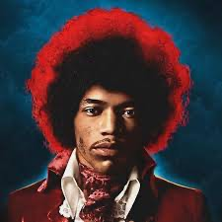Image 1:

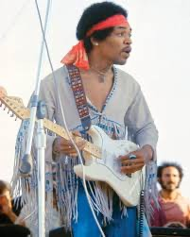Image 2:

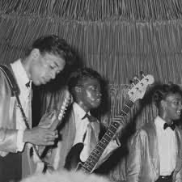Image 3:

footer section

paragraph: Author Info: Nicholas Grande is a Sophomore Music Industry Major at the Frost School of Music. He is from Staten Island, NY and currently resides in Miami, Florida. He is a Jimi Hendrix enthusiast and currently a student in the University’s Web Lab class.